**COSC 3352- Mobile Programming  
Spring 2021**

**Assignment #2  
Date Assigned: Friday, March 25, 2022  
Due Date: Monday, April 4, 2022**

Homework Description:

Using Android Studio, produce the reverse **Hot Wire Game app.**

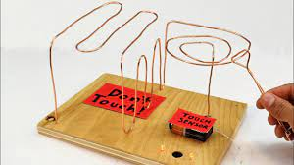

Main screen of the app is a custom view displaying the game field, as well as the game state.

Hot wire is represented as a sequence of line segments, displayed on canvas with the style and color of your choice. A player touches the start point (or closer to it than a certain distance) and drags the wire to the end. Tracing the wire is defined as not getting farther than 10 points (or another suitable constant) from the line. Distance between the finger and the line segment is calculated using vector math; for one explanation, refer to the link:

<https://www.geeksforgeeks.org/minimum-distance-from-a-point-to-the-line-segment-using-vectors/>

Player has 3 “lives”; remaining lives are displayed on screen. Game displays message when player loses a life, loses the game, or wins. Adding sound effects is optional. The game should retain state on rotation or when user switches apps.

**NOTE:** Submission: submit your app's .apk file via Blackboard. Also, submit your code to GitHub Classroom.

<https://classroom.github.com/a/tz70oiPR>